**Objectives:**

Solve SAT/ACT released test questions.

|  |
| --- |
| *Monday, 12.9.24*  **Discuss the previously assigned class work/homework problems**, restated below:   1. Find the sum of the first 10 terms of the geometric sequence 24,12,6,⋯. 2. Find the sum of the infinite geometric sequence 27,18,12,8,⋯. 3. Find the sum of the infinite geometric sequence **8,12,18,27,⋯ if it exists.**   **Class Work/Homework:**  *Released SAT/ACT Questions*   1. If **2x + 2x + 2x + 2x = 216**, what is the value of *x*? 2. The lengths of 2 sides of a triangle are 4 and 9. What is the greatest possible integer length of the third side? 3. The average (arithmetic mean) age of a group of 15 men is 40 years. If 6 additional men are added to the group, then the average age of the 21 men will be 44 years. What is the average age of the 6 additional teachers? 4. Let ***f*** be a function defined by ***f(x) = x2 + 18***. If ***a*** is a positive number such that ***f(2a) = 3f(a),*** what is the value of ***a***? 5. SAT Circle QuestionThe ***coordinates (x, y)*** of each point on the circle below satisfy the equation ***x2 + y2*** ***= 25***. ***Line m*** is tangent to the circle at point C. If the x-coordinate of point C is 3, what is the **slope** of ***line m***? |

1. What is the length of CD in the figure below?

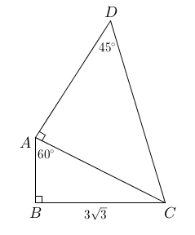

*Wednesday, 12.11.24*

**Homework Check and Discussion of the previously assigned problems.**

**Class Work/Homework:**

1. A car traveled 10 miles at an average speed of 30 miles per hour and then traveled the next 10 miles at an average speed of 50 miles per hour. What was the average speed, in miles per hour, of the car for the 20 miles?
2. The function ***f(t)*** below represents the current total population of sand sharks off the coast of Greenland ***t*** years after 1980. To the nearest year, how many years did (or will) it take for the sand shark population to be 10 times larger that it was in 1980?

***f(t) = 800(1000) t/27***

*Friday, 12.13.24* **___ B-Day, No class**

**Note the GTCHS Midterm Exam Schedule Below. You may use your notes and calculator when you take your midterm exam for this class.**

